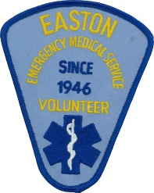
THE EASTON VOLUNTEER
EMERGENCY MEDICAL SERVICE, INC.
P.O. BOX 62 • EASTON, CONNECTICUT 06612 • 203.452.9595 • www.eastonems.com

September 2016
Dear Easton Neighbors,
Easton Emergency Medical Service (EVEMS) is a 501(c)(3) non-profit organization that has been dedicated to providing emergency services to the residents of the town of Easton since 1946. This year Easton EMS is celebrating its 70th Anniversary as well as making Easton a HEARTSafe Community. This program establishes minimum criteria which the communities must meet in order to achieve the HEARTSafe status. The criteria include widespread CPR instruction, public access defibrillators, and aggressive resuscitation protocols for first responders and area hospitals.
In the past few years, EVEMS crews have responded to an average of 400 calls per year for medical help in our community. We’ve responded to emergency calls in your neighborhood and possibly responded to you or your family’s request for emergency assistance.
Your donations from the last 2 years enabled us to purchase 2 LUCAS® Chest Compression Systems and provide the associated training which allow us to perform CPR in the most efficient way possible. We also purchased one Stryker Stretcher PowerLoader. This allows our ambulance stretcher to be loaded automatically without risk of injury to our crews or patients. In addition, we were able to grant scholarships to several Easton residents to enable them to pursue the required education and certification to serve as Emergency Medical Technicians in our town.
Our goal for this year’s annual fundraising appeal is to raise enough money to purchase equipment that will keep our service members safe while providing quality, effective care to our community.
Your contributions will help to keep EVEMS equipped and ready to go. Please donate generously.
Thank you,
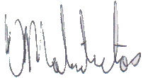
Victor Malindretos
President, EVEMS, Inc.
EVEMS welcomes new members. Please call our headquarters at (203) 452-9595 or visit www.eastonems.com for more information. You can also visit us on Facebook.
Paypal is also welcome.
YES, please accept my tax deductible donation* to support the work of Easton Volunteer EMS: Enclosed is my contribution of:
□ $25 □ $50 □ $100 □ $500 □ Other Amount $_______________
Name: _______________________ Address:_______________________________
* Easton Volunteer Emergency Medical Services is a 501(c)(3) non-profit organization.

