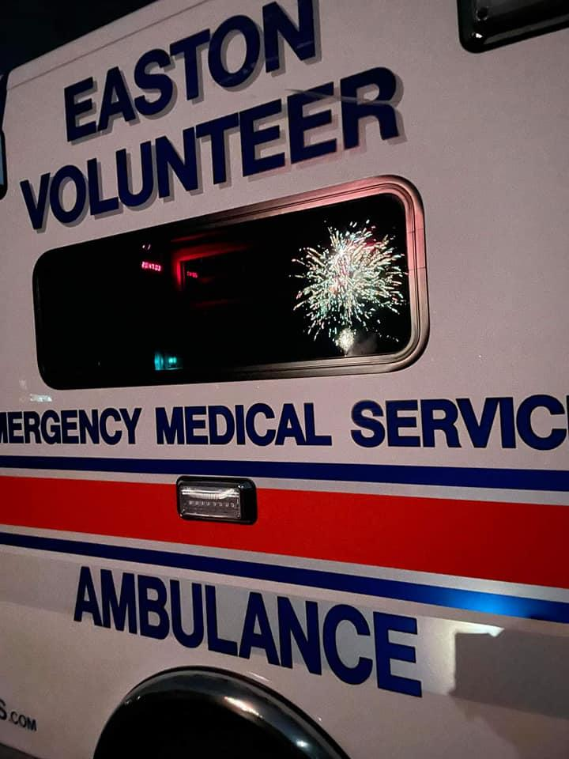
Easton EMS Annual Fall
Fireworks
hosted by:
Easton Volunteer EMS Inc.

Join Us on September 10, 2022 For A Fireworks Display At Samuel Staples Elementary School/Morehouse Fields

Gates open at 5:00pm
Show will begin at Sundown

$40 per car- Online purchase
$40 per family/car *cash exact change*- At gate
Free T-shirts at gate, First Come First Serve
Food trucks on site!
Restrooms will be available
Rain date: September 16th
Questions? Contact JArnold@eastonems.com or call (203)-452-9595
*Event brite link* ( to be posted soon!!!!)
All proceeds go to the Easton Volunteer EMS “New Building Fund” 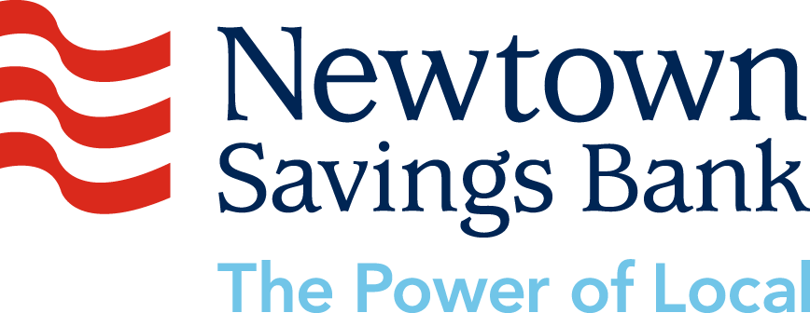
Relax into Meditation

